Name- Himanshu Panwar

Course- MCA ‘2B’

# Student id- 20711120

ANSWER 01:

Steps for network design, IP configuration and connectivity are:-

Step 1: Drag and Drop 2 PCs from ‘End Devices’.

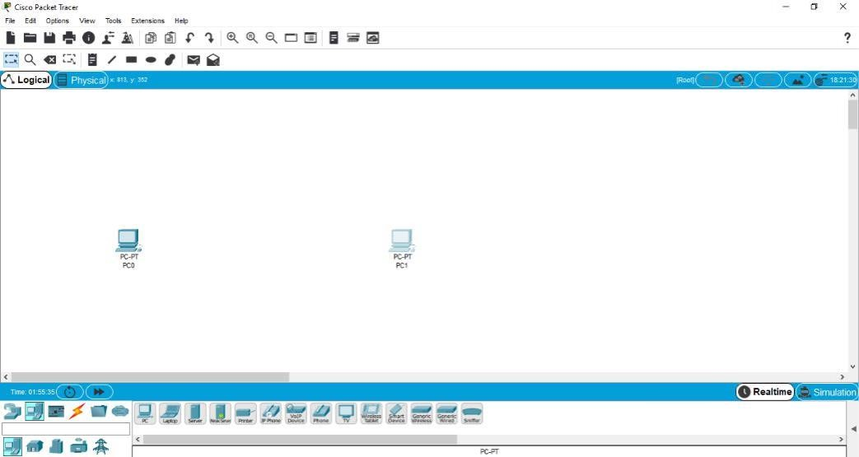

Step 2: Now you have to drag ‘Cross-Cable’ from connection and drop on 1st PC where you will select ‘FastEthernet0’ from list.

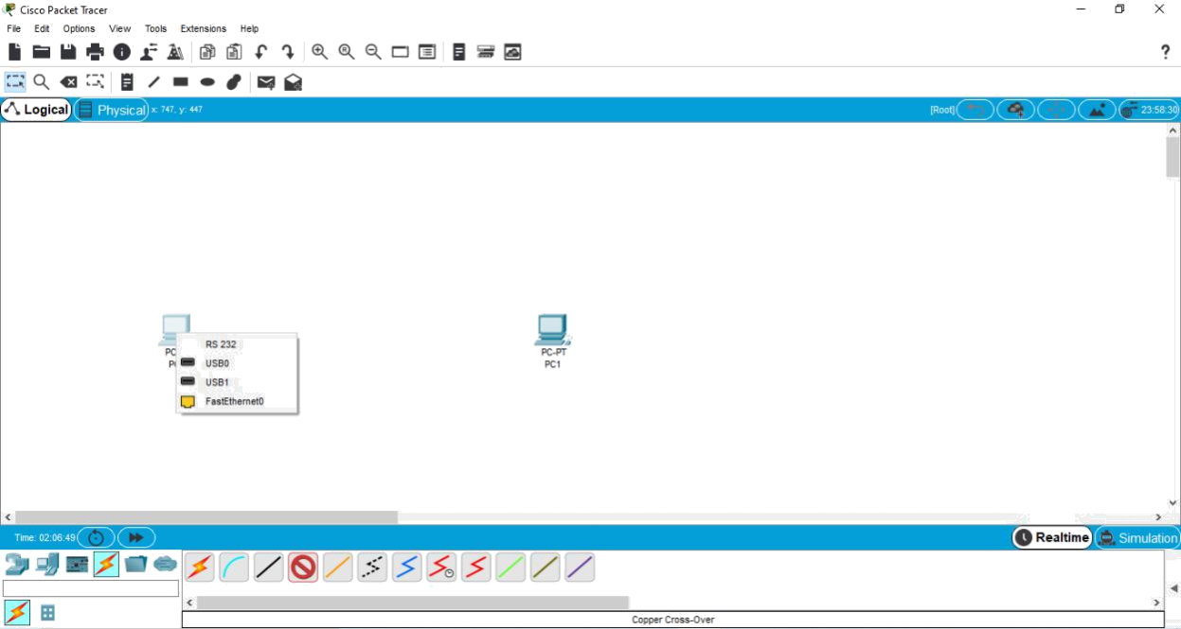

Step 3: Now connect the cable to 2nd PC and select ‘FastEthernet0’ from list.

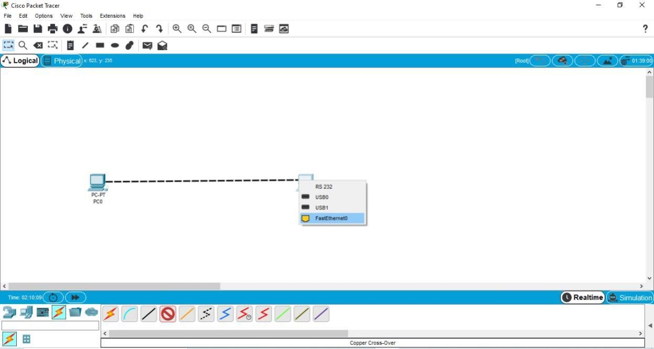

Step 4: This will be the resultant **Network for connecting 2 PCs**.

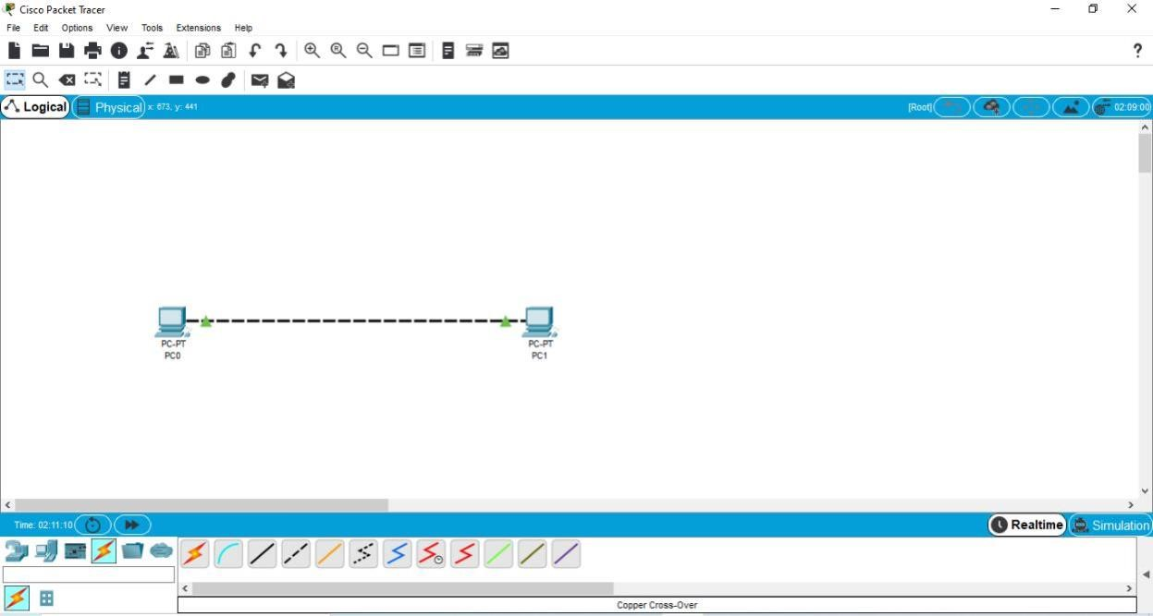

Step 5: To configure the IP Address. Click on 1st PC. A screen will appear, go to ‘Desktop’.

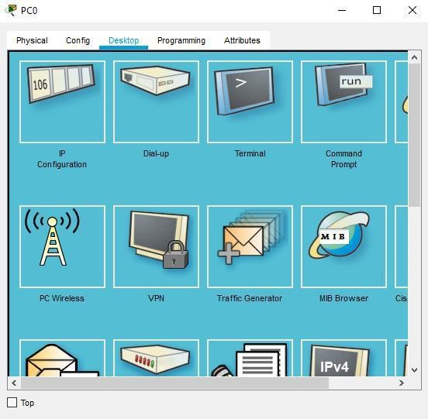

Step 6: Click on ‘IP Configuration’. This screen will get appear.

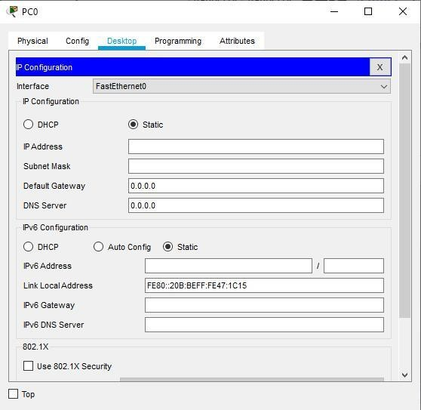

Step 7: Write the IP Address in the ‘IP Address’ section. Then click on ‘Subnet Mask’, it will get filled automatically.

Continue Step 5 to Step 7 to get IP Address for 2nd PC.

Here is the **IP Address for both the PCs.**

